**Igbo Woven motif Symbols: Origin, Types, cultural Significance and Modern Transformation.**

**By**

**Chika Chudi – Duru**

**Department of Fine and Applied Arts**

**Imo State University, Owerri**

[**chinyeogwa@gmail.com**](mailto:chinyeogwa@gmail.com)

**Abstract**

The Igbo woven cloth known as Akwete is usually recognized with its woven motif symbols. The Igbo woven symbols found on Akwete woven fabrics are expressions of Igbo philosophy, beliefs and history. These symbols were woven by the Akwete women and are still being woven till date. They are rich in hidden meanings, allowing the weavers to make particular statements with their woven pieces. Some of the symbols depict human and animal behavior, important events, while others depict geometrical shapes and plants all in abstracted forms telling a particular story. This paper traces the origin of these symbols because it believes that they must have originated from somewhere. The study also focuses on the types of the symbols used by the women weavers both the old and the new; with emphasis on the borrowed and copied motifs. The study presented the historical view of some borrowed and copied motif symbols and patterns of the woven cloth. In the process, three categories of the Akwete woven cloth were discussed based on their decorative symbols and weaving patterns. This paper identifies the cultural significance of these woven symbols, how and when they are used and their modern transformation in Igbo land since Akwete woven symbols still incorporate new ideas. It finally highlights the changes brought about by the Indian Madras, george and Ghanaian weavers and recommends the numerous ways in which these design symbols can be utilized other than being woven on cloth to aid their sustainability.

Key words: Symbols, Woven Symbols, Akwete Woven Fabric, Modern Transformation

**Introduction**

A symbol could be defined as an object, word or caption that represents another thing (usually abstract) even if there is no meaningful relationship. Symbolism is when something represents abstract ideas or concepts. According to Schultz and Robert (2009), symbols are the basis of any culture. Some examples of symbols are objects, figures, sounds and colours. Symbols could mean different things to different people that is why it is impossible to hypothesize how a specific culture will symbolize something. Some symbols are gained from experience, while others are sourced from culture. In African societies, symbols have been used to express different cultural ideas in art and design. In Nigeria, most ethnic groups have different symbols which have been utilized by artists and designers to decorate and produce different items. They could be written, drawn, painted, tattooed, carved, woven, printed, dyed on fabrics and even sculpted to portray some meanings to the onlooker. These symbols can at best be understood and interpreted by the particular culture that owns them or else they may lose their significance.

Millar (2011) supported Schultz and Robert (2009) and observed that symbolic representation which identify and illustrate our cultural ethos could be found in our societies today. Examples are the Akwete woven symbols Ndigbo. They are woven onto the cloth to showcase Igbo ideologies and beliefs. They evoke emotional feelings and are also important integral elements in understanding Igbo world view. Every symbolic motif of Akwete has a story to tell. Anthropologist Victor turner in Millar (2011) believed that symbols are not just vehicles for meanings but by their very use they create meaning, understanding and solidarity in relationships. He observed that symbols do not always remain the same, but can be transformed through the ages and through various processes of cultural adaptation for sustainability and different purposes.

**Africa and symbols**

According to Dzobo in Isiguzo (2015), African world view is replete with symbols. African symbols provide of insights into African orientation to life. They are used to communicate complex knowledge. They convey information concerning the way of life of a people at every situation they are presented or the history of the society it represents. Griffis (2008), believed that the meanings of these African symbols are derived from inspirational proverbs, human attitudes and beliefs, concepts related to abstract shapes, cultural meanings as well as other historical events and religious beliefs. He further gave examples with the Adinkra symbols by the Asante group of Ghana which dates back to around the 16th century. These Adinkra symbols are still widely used to this day to convey specific messages through a wide range of products and crafts including Adinkra cloths, clothing accessories, home decoration items, greeting cards, architecture, pottery, logos, advertising and more. They are a major influence in African art to this day, and can also be found in wood carvings, traditional printed cloths, furniture and other mediums.

In Nigeria, there are lots of symbolic motifs belonging to each ethnic group which are highly appreciated by the different cultures that own them. Cole and Aniakor (1986) describe the symbols of the ukara cloth worn by the ekpe society in Igbo land as the representations of the repository of power in the society. They further stated that the squares or rectangles motifs of the cloth are composed of four design types of concentric rectangular boxes with various chequered patterns, representational motifs such as fish, scorpions, crocodiles, hands in friendship, war and work, masks, moon and stars are dyed on ukara cloths which are symbolic representations of cultic power. Other symbols include abstract or geometric signs from sect writing systems known as Nsibidi. There are naturalistic and abstract references such as the bold, chequered patterns, which symbolize the leopards multiple spots, thus representing the leopards claws and then symbolize the Ekpe society power. The pythons and crocodiles also refer to the fearful and mystical power of ekpe society. Akinbileje (2014) mentioned that ekpe symbols and titles have persisted as an expression of leadership authority even with the advent of missionaries and colonial enterprise in the nineteenth century. Also the Nsibidi symbols have also many Nigerian contemporary artists. The Igbo also have the Uli/uri symbolic motifs which are painted on the body, walls of houses and shrines. While all these motifs are drawn and painted on various, they are nevertheless not woven like Akwete motifs. The Igbo woven symbols found on Akwete fabrics have not been sufficiently utilized by contemporary artists and designers for their creative potentials.

**Igbo woven motif symbols.**

These are the motif symbols woven on the Akwete fabrics. Negri (1976) in Aniakor (2002) in Ofomata (2002) views the prestigious Igbo cloth known as Akwete cloth as that which utilizes rayon or other synthetic threads to make the floated patterns found on the woven cloth. And these patterns consist of symbolic motifs which confer status and prestige to the woven cloth. The woven symbolic motifs are arranged on the woven cloth to form some patterns in the designs of the woven fabrics by utilizing the elements and principles of design. Akwete woven symbols are created, woven and developed by the Akwete women weavers of Akwete town in Ndoki and Asa areas of Ukwa East local government area of Abia state, Nigeria. Ikegwuonu (1979), Nwachukwu& Ibeabuchi(2012) believe that this weaving tradition is as old as Igbo land. Ekwueme (2009) narrates that the Akwete clans’ ancestors came from Bonny in Rivers state; maybe that could explain why Umuagbai-Ndoki,Ijo and Ogoni in Rivers state also weave a cloth called Akuraku (Ikegwu &Uzuegbu 2015).They further mentioned that this weaving vocation was projected into limelight globally by the colonial masters. But Ekwueme(2009) maintains that Akwete woven fabrics gained popularity during the oilboom era. This trade was what brought the beauty and creative symbolic designs of Akwete into limelight globally. However, the Akwete woven symbols have always remained popular in the history of Nigerian textiles. Adetoro (1984) also sees Akwete weaving as one of Nigerians’ traditional textiles. Ogu&Ndebilie (2011) have a report that every woman in Akwete knows how to weave and the younger ones are taught to weave as soon as she can operate the narrow wall loom. They are woven onto the fabric with the aid of the women’s vertical loom Chukueggu (2000) stated. They can be used to communicate evocative messages that represent parts of their life or those around them. They have unique looks and meanings. Some of them represent popular inspirational proverbs and maxims, record historical events, express particular human attitudes or behavior related to depicted figures or concepts uniquely related to abstract shapes. Some of the woven designs have always been personal expressions of the weavers. According to Ikegwuonu (1979) in Chukwueggu and Ogu (2013) Akwete fabric designs are derived from legend stylized human, animal forms, creatures, everyday life, conceptual symbols and inspirations. Akwete symbols are associated with rich Igbo tradition dating back to 9th century. They are still woven and used till date to convey specific massages through the woven fabrics.

Although the woven symbols are not reserved for a particular group of people, that is; is not only Ndigbo that utilize the woven fabrics, they still have significant meanings for the people that use them and their owners. According to Kashim (2013) akwete fabrics are woven materials produced in attractive designs with rich colours for male and female.

**Origin of these motifs.**

All the motifs incorporated in Akwete weaving originated from somewhere. Some of the weavers claim that they get some of their designs in dreams, some of them were created by the weavers themselves according to Lady Ordor, an Akwete weaver that was met by the researcher in 2015.Some of the weavers are motivated by getting inspiration from the surroundings, Igbo beliefs, traditions, folklores and Igbo worldview.

Aronson (1979) narrated the story behind the origin of the popular ikaki symbolic motif and proclaimed that Akwete Igbo weavers have come to appropriate a wide range of foreign – introduced patterns, including those from Ijebu Yourba area. She further narrated that Ijebu Yourba who live in south eastern Yoruba land were ruled by a divine King based in ijebu – ode. There is a separate but not related system of Ijebu rule called Oshugbo (Ogboni by other Yoruba subgroup). This system is the judiciary society. It is made up of male and female elders who decide on criminal court cases and who oversee all affairs concerning the king. Ijebu women weavers manufacture the ritual attire that all Oshugbo members must wear. Such a cloth is referred to as aso olona meaning “cloth with patterns”. It is a large wrapper made up of 4 full wide panels sewn together along the selvedge and worn toga – style on the body. There is also the single panel of cloth called an itagbe which is worn over the left shoulder or as a turban on the head. They wear this ensemble of cloths for the purposes of public display. It combines the ooni (crocodile) motif with a shaki feature (shag) it symbolizes power, prestige and things that are good. Aronson (1980) stated that elsewhere in Yourba land the members of ogboni tend not to use Ijebu woven cloth as standard attire. She found out that cloths bearing identical patterns to Ijebu cloth are found in cloth collections among the Ijo group living at the east end of the Niger Delta which is more than 100 miles from Ijebu land. She strongly believed that trade seems to have been the impetus for the spread because the Ijebu yourba have been known to be vibrant cloth traders. The Ijebu cloth may have been among the cloths transported to Niger delta. For two centuries, the kings of Eastern Ijo have worn cloths bearing Ijebu – like patterns as their official attire. The patterns bear a striking resemblance to the Ijebu counterparts but bear a different name (Ikaki) the meaning in Ijo is tortoise. This motif symbolizes tortoise as a highly revered own (water spirit) whose wise and cunning and tricky behavior Ijo kings and chiefs have been known to copy. This Ikaki has been made official attire for the royalty since the late 18th century and this suggests that Ijebu cloth were being traded to the Ijo by this early date.

Recently in the 19th and 20th century the Ijo kings (amanyanabo) cloth are woven by the Akwete Igbo women weavers confirming that they have taken on the role of replicating imported cloth types. They no longer buy from ijebu weavers but they place orders for the woven cloth in Akwete. There was an attachment and liking for imported cloths by the eastern Ijo to a height that local weaving production became affected. Very close to the Eastern Ijo in the north are the Ndoki people in the village of Akwete, with whom the Eastern Ijo were trading heavily for slaves and palm oil in the 18th and 19th centuries. Through such commercial contact women weavers of Akwete gained expert to imported cloth patterns familiar to their eastern Ijo patrons. By the end of 19th century in the midst of competitive trading amongst the coastal and inland groups weaving in Ndoki village of Akwete was revolutionized.

Aronson (1980) and Davis (1974) asserted that oral tradition tells a story of an innovative and pioneer weaver named Dada Nwakata who exhibited highly outstanding professional skill, invented and wove hundreds of new patterns executed with imported cotton threads.This made her fabrics the toast of clients. According to Afigbo and Okeke (1985), she unravelled the mystery behind the Indian woven materials sold by the portguese and produced the designs using the Akwete loom. Dada Nwakata wove reversible patterns that appear in the front and back of the woven wrapper. Aronson (1979) argued that it would have been to please her wealthy to patrons. Since the late 19th century Akwete weavers have continued to weave cloths for Eastern Ijo consumption that bear patterns such as ikaki which was initially introduced to the Eastern delta from the Ijebu yourba area. Akwete weavers have become innovative in the ways which they weave Ikaki and other patterns. This research found out that many new motifs that form patterns that symbolize a lot of things have been incorporated in the recently woven Akwete cloth. They have particular propensity for innovation. Aronson (1980), Davis (1974) and Lamb and Holmes (1980), said that the women weavers wove numerous motifs which were used in forming patterns of designs. These patterns have complex combinations. For example no two cloths bearing the Ikaki motif are alike forming a contact to the traditional Ijebu version. Atimes other symbolic, motifs from other parts of West Africa bearing the names of what they feel it looks like will be given to it making it purely Akwete woven cloth. In naming it such, the trend towards creativity and innovation and the very weaver who introduced it, lives on forever in the Akwete Igbo area of Nigeria. According to Lamb and Holmes (1980) akwete woven cloth can be divided into three main categories. This study found out that this categorization is based on the different designs woven on the akwete cloth which symbolize and connote a lot of meanings. All the Akwete woven fabrics fall under the three categories. The three main categories are:

1. George cloth
2. Popo cloth
3. Akwete

**George Cloth**

This type of woven cloth has designs of stripes and checks. Aronson (1980) supported Lamb & Holmes (1980) and explained that in the compound where she was residing during a research in Akwete she encountered a woman using a piece of Indian madras known locally as George cloth as the prototype for the design she was weaving. These Indian madras cloths are characterized by their colourful plaid designs. Nnadede is an example of this george. It also has an Indian source. They further mentioned that all the numerous Akwete plaid and check designs are derived from Indian imports and could have resulted from requests by the Ijo patrons to duplicate designs that were particularly favoured. Cloth designs that have been copied from Indian madras come under this heading.

|  |
| --- |
| C:\Users\USER\Desktop\chiko's research pic\Chiko's research pictures 608.jpg |
| Mrs. Nneoma Okere,an Igbo of Akwete ,working on an Akwete cloth, utilizing the ikaki (tortoise), igbe akwukwo (box of books) and ute (mat) designs to weave. Source: researcher (2015). |
| C:\Users\USER\Desktop\chiko's research pic\Chiko's research pictures 629.jpg |
| Akwete woven fabric comprising of ikaki,comb, ruler and checkerboard designs.Weaver:Mrs Helen Brown mother to Mrs Nneoma Okere.Source: researcher (2015). |
| C:\Users\USER\Desktop\chiko's research pic\Chiko's research pictures 603.jpg |
| Nnadede design being woven in a loom. Source: reseacher (2015). |

**Akwete**

This type refers to the type woven cloth produced by the women weavers using their own designs motifs. Aronson (1980) mentioned that the Akwete weavers used to make some rather simple cloth of traditional patterns of black and white warp stripes which has an overall effect of small checks and some with further embellishment of the water stripes with arrays of holes which belong to the wider tradition of the Nigerian woman’s vertical loom.

**Popo Cloth**

According to Lamb and Holmes (1980) and Talbot in Aronson (1982), it is a fact that the male Ewe parallels of weaving can be found easily on the popo cloth of Akwete but its origin is from Ghana and Togo. Lamb and Holmes (1980) further explained that it is a type of cloth woven for sale in opobo market and also in Bonny in deliberate competition with the Ewe cloths from Keta and Togo. It is still held in high esteem among the women of Ijo because of its importance.

**Symbolic Motifs of the Akwete woven cloth**

Motifs are decorative figures that are represented in a design. Every good design has repetition as a principle of design. The women weavers of Akwete made good use of motifs. The motif woven onto Atwete cloth and the size are the major features that distinguish it from other traditionally woven cloths in Nigeria. These motifs have a lot of symbolic meanings to the weaver, wearer and the admirers. For one to differentiate one motif from the other, names were given to these motifs and symbolic meanings were attached to them making the motifs to become symbols that is the motifs woven on the cloth become objects which are meant to represent another (usually abstract) even if there is no meaningful relationship. Okeke (1996) and Ikegwuonu (1979) lend support to this and agreed that every Akwete fabric bears a name which sometimes is named after the weaver or after the motif used for the design. This study believes that those names used to represent those designs are symbols. Lamb and Holmes (1980) and Aronson (1980) reported that the Akwete women have produced a lot of designs (over a 100) using different motifs. This study confirmed this during a research in Akwete town. The women weavers have a lot of traditional motifs which have are still being utilized in weaving till date. Some of them claim that they conceive their designs through dreams. They also claim that they are capable of creating an almost infinite array of designs and also adopt motifs from all sorts of external sources. They are familiar with copying from prototypes, and this stems from the Ijo people who use varieties of cloth and are always looking for ways to replicate designs that are out of the market. Till date they still claim that they capable of creating an almost infinite array of designs and also reproduce any design found or given to them. Aronson (1980) mentioned that many designs woven have names relating to object in the weavers environment. They could also deviate from the prototype to create new designs. This study found out that all these designs symbolize one important thing or the other in Igbo land.

There are so many ways in which the designs woven on Akwete Cloth are conceived. Some were/are conceived from dreams. Lamb and Holmes (1980) mentioned that the distinctive symbolic designs which give many Akwete cloths their particular character are attributed to Dada Nwakata as mentioned earlier. During a research by this study in 2015 in Akwete town,a weaver named Mrs. Nneoma okere confirmed this and rated Dada Nwakata and Madam Goerge Mmeribokwu and as first class weavers. She also mentioned that Dada Nwakata created these designs in secret to prevent others from copying her ideas and when she died she cast a spell on her loom to prevent inquisitiveness. She wove designs that had symbolic motifs woven on one side but can be seen on both sides while Madam George wove George materials.

Lamb & Holmes (1980) further noticed that Akwete cloth comes in different patterns and motifs. And this study also found out during a research in 2015 that these motifs have symbolic meanings attached to each and every one of it. Each motif symbols have names attached to it. When they are woven on to the Akwete cloth, they design could be called another name. Up to a number of four different motif symbols could be woven onto a particular cloth after which one name is chosen and given to the design/pattern woven for example. Davis (1974) reported that some Akwete weavers wove a lot of motifs, though they seldom use more than three or four in one cloth. Many motifs are variations of one another, and the ones included here arc those most frequently seen. Any special circumstances sur­rounding the development of a new motif usually involve cither the weaver or the wearer, and traditionally the creator of a new motif receives an unwritten "copyright," Some motifs appear to be traditional to certain families, though frequently the same motif may be given different names by different weavers. Ac­cording to some contemporary weavers, certain motifs were gifts of creative inspiration from a divinity to favored weavers, and it was forbidden for any other weaver to use such a motif. When that weaver died, the motif could no longer be made, and existing cloth con­taining it increased in value and prestige. While motif ideas are no longer con­sidered divine in origin, there are a few very old ones that it would be considered unlucky or disrespectful to reproduce. There are some other woven pieces which do not necessary bear the name of what was woven on them. Most of their names could be tittles given to a hero and the motif symbols woven onto the cloth represent the name.

**Some symbolic Akwete motifs. Source Davis (1974) and researcher (2015).**

|  |  |
| --- | --- |
| C:\Users\USER\Desktop\Scan d.jpg | **Checkerboard** |
|  |  |
| C:\Users\USER\Desktop\Scan d.jpg | **Snake** |
|  |  |
| C:\Users\USER\Desktop\Scan d.jpg | **Tortoise** |
|  |  |
| C:\Users\USER\Desktop\Scan d.jpg | **Geometric Flower** |
|  |  |
| C:\Users\USER\Desktop\Scan d.jpg | **Snake back** |
|  |  |
| C:\Users\USER\Desktop\Scan d.jpg | **Corn** |
|  |  |
| C:\Users\USER\Desktop\Scan c0002.jpg | **Necklace** |
|  |  |
| C:\Users\USER\Desktop\Scan c0002.jpg | **Saw** |
|  |  |
| C:\Users\USER\Desktop\Scan c0002.jpg | **Key or Children’s Fingers** |
|  |  |
| C:\Users\USER\Desktop\Scan c0002.jpg | **Chain** |
|  |  |
| C:\Users\USER\Desktop\Scan c0002.jpg | **mboisi** |
| C:\Users\USER\Desktop\Scan a.jpg | **Scissors** |
|  |  |
| C:\Users\USER\Desktop\Scan a.jpg | **Snake back** |
|  |  |
| C:\Users\USER\Desktop\Scan a.jpg | **Stool or bow tie** |
|  |  |
| C:\Users\USER\Desktop\Scan a.jpg | **Variations of Ebe Motif** |
|  |  |
| C:\Users\USER\Desktop\Scan j.jpg | **“V”** |
|  |  |
| C:\Users\USER\Desktop\Scan j.jpg | **Knees of the Beautiful people** |
|  |  |
| C:\Users\USER\Desktop\Scan j.jpg | **Zigzag or (Dakuru) the name of the designer** |
|  |  |
| C:\Users\USER\Desktop\Scan j.jpg | **Nigerian Coat of Arms** |
|  |  |
|  | **Z** |
|  | **Variation of ebe** |
|  | **Double bell** |
|  | **Variation of necklace** |
|  | **Variation of ikaki** |
|  | **Isi ajuala** |
|  | **Variation of scissors** |
|  | **Ahia** |
|  | **Kpakpando** |
|  | **Single bell** |
|  | **Variation of ebe motif** |
|  | **Broken v** |
|  | **Ngaji** |
|  | **Mboisi- isi abuo** |
|  | **Mkpuru ludo** |
|  | **Variation of okwuepele** |
|  | **Mkpekele efere** |
|  | **Butterfly** |
|  | **Okpueze** |
|  | **Cross** |
|  | **A borrowed Asante motif from Ghana** |
|  | **Ruler** |
|  | **Epele** |
|  | **Iyerinti/olanti** |
|  | **Ocean in the river** |
|  | **Heart** |
|  | **Kuferemmiri (across the river)** |
|  | **Biscuit** |
|  | **Hand fan** |
|  | **Mgbawa tomatoes(broken tomatoes)** |
|  | **Ceiling fan** |
|  | **Fancy block** |
|  | **Nnunnu(bird)** |
|  | **Igbe akwukwo(box of books)** |
|  | **Variation of block** |
|  | **Anthropomorphic motif** |

This study found out that the names of some of these motifs are in ijo language while most of the motifs have Igbo names. While some of them have ijo names stems from the fact that they are Akwete towns neighboring villages, they normally patronize the weavers a lot and these woven cloths play a lot of cultural significance role in ijo areas. Most of these motifs woven on to the cloth attached a lot of importance to the woven cloth and also enabled the weavers to attract more customers because any new design motif woven will be sought for by someone that has never had it before.

Some of the designs and symbolic motifs found during a field research in Akwete (2015), are as follows:-

1. Akajiaku 2. Volvo
2. Air conditioner 4. Oil boom
3. Nnadede 6. Ikaki
4. Aziza 8. Igbe Akwukwo
5. Ebe 10.Nigerian Coat of Arms
6. Two bells 12. Mkpuru Sugar
7. Fancy Blocks 14. Butterfly
8. First lady 16. Baby lace
9. Ruler 18. Broken plate (Mkpekele efere)
10. Kpakpando (star)
11. Ahia (utilization of many heddles to produce complicated designs that do not have specific names.)
12. Hour glass 22. The knees of the beautiful people (ikpere

ndioma)

1. Ute (mat) 24. Fig (popo pattern and its variations)
2. Comb (mboisi) 26. Mkpuru ludo
3. Snake 28. Flower (geometric in nature)
4. Mkpuru oka (corn) 30. Dakuru (zig zag)(she started weaving

this design)

1. Popo patterns 32. Checker board
2. Crown 34. Igbe Akwukwo (box of books)
3. Zoomorphic motifs 36. Necklace
4. Saw 38. Key/children fingers
5. Chain 40. Scissors
6. Snake back 42. Stool or bow tie
7. Wine glass 44. Cross
8. Fruit of the oil bean tree 46. “V boot”
9. Christmas tree and parcels 48. Heart/love
10. Azu 50. Pivot
11. Stool 52. Ritual objects
12. Nigerian flag 54. Logo of festac (the 2nd All black festival

of the Arts held in Nigeria 1977)

1. Eating utensil (spoon) 56. Single bell
2. Anu Kpo Anu (animal eating animal) 58. Okwa epele
3. Mirror in the sun 60. Nnunnu (bird)

61. Ishi ajuala 62. Okwa

63. Double 8 64. Aka abuo (two hands)

65. Ugo (eagle) 66. Ijikoaka onu (unity)

67. Ocean in the river 68. Akisi igbebiri (Ijo name)

69. Eye witness 70. Ajari (George)

71. Rainbow 72. Anya pussy-cat (pussycat eyes)

73. Flower 74. Afo ikaki

75. Ukwu bench 76. Okpuru afo eke (pythons belly)

77. Isafela 78. Inyingi

79. Madam pass madam 80. Mgbawa tomato (broken tomato)

81. Ceiling fan 82. Standing fan

83. Biscuits 84. Kufere mmiri

85. Ijeagwo 86. Brocade

87. Dada nwakata 88. Fancy block

89. Hand fan 90. Five stars

91. Anthropomorphic motifs 92. Mkposu

93. onwa 94. Block

95. Oche eze 96. ebe afo mkpo

97. ebe olu ngalasi 98. ebe uhie

99. ebe agharigha 100. Akpukpa/Ogbanaonweya

1. *Agbani* 102 *Ovation*
2. *Rekereke* 103 *stainless*
3. *Toll gate* 105 *Oceanfish*
4. *Ifuru Osisi* 107 *Afro*
5. *Ayarawo* 109 *lace*
6. *Fii- fii* 111 *babwaya*
7. *Okere bebe* 113 *Egbe otuzo*
8. *Otuzo Umunwaibari* 115 *Azuerigh agwu*
9. *Ikpere aturu* 117 *ishianu*

118  *Obuenyi* 119 *ifuruosisi*

They all have meaning in Igbo tradition, myths and beliefs. Plants, animals and geometrical forms are widely used to represent specific, meaning in particular art forms. Motifs are drawn from nature – leaves, flowers, animals. Certain motifs were favoured and even restricted to the royal families. These symbols depicted that they were important to the lives of ndigbo. Textiles played significant role in Igbo Society and have continued till date; Akwete fabrics are being utilized in most of the chieftaincy coronations in Igboland and the neighbouring Ijo areas of River state in Nigeria.

According to Lamb and Holmes (1980) Akwete cloth comes in different patterns and motifs. Most of the symbolic motifs are found on one side but can also be seen on both sides and they are named according to their appearances while some of them are not. For example the woven symbols found on the Akwete cloth called akajiaku which means a wealthy person does not even comprise of a human being but an intricate complicated design. This shows that for one to afford it, that person has to be wealthy.

They further observed that privileged wearing of certain motifs has depended on the wearer's role. For example, some styles of the ebe were traditionally reserved for wear by roy­alty or for use as talismans in protecting a pregnant woman or warrior going to battle. Ebe motifs symbolize protection. Other patterns were reserved for special families or occasions because of the circumstances surrounding motif origin. One example of this is the Nnadede cloth. It is one of the few presently known two-faced, or revers­ible, designs of Akwete cloth in which the woven pattern appears identically on both sides of the cloth. It is usually a symmetrical design composed of rectan­gles formed by intersecting vertical and horizontal thin stripes. A dot, or "star," is woven alternately in the center of the rectangles. Wider stripes divide the cloth into two sections. A story that was told of its origin tells of Nnadede a famous man in the Akwete area in the 1860s for his vic­tories in war. During one of his triumphal returns, his father presented him with a beautiful cloth designed and woven es­pecially for the occasion. For many years that pattern was reserved as a status symbol and for ceremonial dress, but it gradually took its place among the commonly used traditional Akwete de­signs. Nnadede cloth symbolizes bravery and victory. Today it is still highly regarded, both because of its lore and because of the skill required to weave the reversible cloth. It is sometimes referred to as "star" cloth after some similarly pat­terned imported "judge" or "George” cloth with embroidered motifs enclosed in rectangles.

**Cultural significance**

Akwete cloth serves an important function in the context of royalty as have been observed by Aronson (1980).In Igboland, Akwete cloth is mostly used during chieftaincy titling ceremonies and coronations. All the kings’ cabinet members with the Ndinze, Ndiozo and NdiLolo usually adorn themselves in Akwete woven fabrics.

Aronson (1980) further stated that elsewhere in the eastern delta in Nigeria, this cloth has assumed a supreme importance and it’s often associated with elite segments of the society-kings, chiefs and the priestly class. Ikaki cloth bears the emblem of the tortoise called Mbe or Mbekwu in Igboland. Which to the Rivers people (the Ijo in particular) a tortoise is a wise and cunning creature; the same goes to the ndigbo that weave the cloth. It is understandable that a cloth with this name would be would be associated with chieftaincy. In Ijo areas, when a king dies, ikaki will be used to decorate his rooms, where he is lying in state and his sorroundings. Also during the installation of chiefs in office, Akwete is also used as the attire and also for beautifying their homes and surroundings. It is being used as an expression of family wealth, social status and an emblem of power.

According to Aronson (1980) the Akwete woven cloth is utilized by women in some ceremonies among the Kalabari known as cloth –tying ceremonies (egenebite and bibite).These ceremonies are for women who are ready for marriage and childbirth. She found out that they are bestowed with recognition as mature women. In a formal public appearance, a young woman wears selected types of cloth at different stages of the ritual. Ikaki is also worn first before other types of cloth because it is the initial type of cloth brought to the bonny area through trade. She further noticed that among the Kalabari, the ceremony is extended over several months, allowing the woman to wrap one category of cloth for a three –week period before changing to another. Akwete cloth is often one of the first to be tied in the Kalabari event.

Lamb and Holmes (1980) reported that Akwete cloth is worn or tied during ceremonial occasions including attending church and celebrating the major Christian festivals. Prestige can be established by the use of the most elaborate and expensive cloths. They further mentioned that Akwete cloth can also be tailored in to European style clothing though this is neither uncommon nor popular. They mentioned an important role Akwete woven cloth plays in marriage arrangements in Akwete in the past. The dowry of an Akwete girl would have contained ten pairs of cloths of the Akwete category as well as a box or trunk filled George cloths, the possession of a large number of cloths still being equated with the possession of wealth.

They are used as uniforms for group identification. Just like in Yoruba land, societies and associations in Akwete may have a special cloth design. Talbot in Lamb and Holmes (1980) says that in Kalabari, some societies were actually named after the group cloths, some were woven in Akwete. Also different dance groups and cultural organizations identify themselves with a particular Akwete woven design as uniform. They are also used as Ndigbo cultural attire in Nollywood.

**Modern Transformation**

Recently, during a research in Akwete (2015) this study found out that the weavers don’t only replicate foreign designs but they have mastered the art of elaborating on old designs and also inventing new ones. These have formed part of their weaving tradition from the nineteenth century. Aronson (1980) observed that dreams are often cited by the weavers as the source of new designs. One of the weavers met during this study Lady Patience Odor, attested to Aaronson’s observations and claims that the source of her design motifs are from dreams. A lot of variations can be seen in the ikaki woven cloth recently, it is no longer the ikaki design alone but other design motifs have been combined alongside the ikaki so as to meet up with the recent trends in fashion. A lot of intricate designs have been produced by the weavers using numerous ahia (heddles). This study found out that these designs are more expensive than the ordinary ones. Some of these designs woven by using many heddles do not have names they are simply called ahia. Chukueggu and Ogu (2013) further mentioned that the designing of the fabric depends on the taste and trend in the society, market demands and the skillfulness of the craftswomen. Adetoro (1984) mentioned that modern Akwete fabrics are designed using cotton, rayon and metallized yarns usually in brilliant warm and glittering colours with intricate geometric patterns achieved by the in-lay technique. This study found out that most Akwete fabrics bear a name. Eicher and Erekosima (1987), Davis (1974), Okeke (1996) and Ikegwuonu (1979) in Chukueggu and Ogu (2013) supported this and mentioned that every Akwete fabric bears a name which is sometimes named after the symbolic motifs used for the design or after the weaver; they may be named by traders or consumers according to the meaning and purpose attached to the design; examples are Dakuru, Dada nwakata and Inyingi and others.

Chukueggu (1998) in Chukueggu and Ogu (2013) observed that the women weavers make use of cultural oriented motifs which they combine with modern motifs to create modern forms and concepts. He further noted that there are light weave Akwete fabrics. Which this study believes that this has created room for variety because it found out that during the cause of this study that some consumers still prefer the heavy types while some prefer the light weaves. The insertion of the motif symbols are done using matching colours which are different from the background colours. Atimes the weavers copy some designs from each other especially when the design is in high demand after production; quite unlike in the past when the designs can only be woven by the inventor of that particular design that bears the name of that design. Below are the samples of old ikaki.

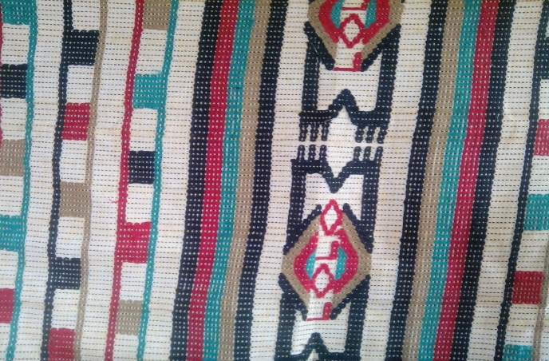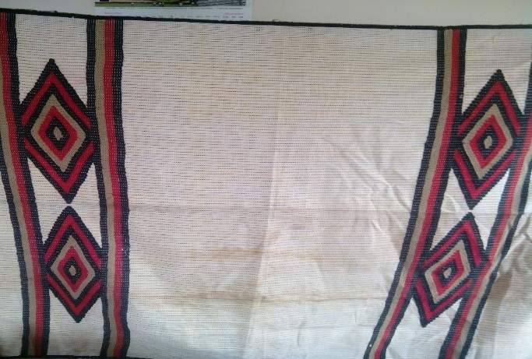

Samples of old Ikaki motif belonging to Chief and Lolo E.C. Uchegbu. Source: researcher 2015 produced late 70’s.

Lambs and Holmes (1980) found out that normally Akwete women weavers adopt motifs from all sorts of external sources. Most of the Akwete woven symbols have been transformed. There have remarkable changes in appearance, woven structures and usage. The weavers make use of modern shiny yarns of synthetic materials in contrast to the older dyed cottons. They also make use of imported cotton yarns but industrially dyed. A lot of research has been carried out on the origin of Akwete weaving, its loom, the cloth itself, the usage, patronage and its various designs; but not much has been done on the utilization of its design symbols and decorating the woven fabrics with stones, beads, trims, sequins and some fanciful metals cut in form of flowers, objects and shapes. Just like the Adinkra motifs which have been utilized in printing of greeting cards, tee shirts, and cloth prints.

**Recommendations**

Akwete design symbols should not only be woven on fabrics alone using the vertical loom as in the case of Akwete women. Other areas like monogramming those design symbols on caps, towels, stoles, shirts and on fabrics for wall hangings should be explored.

They could also be in cooperated in paintings just like the uli motifs, sculpted and carved on wooden doors for decoration purposes to also depict Igbo culture. These designs can be adapted as designs on hand woven rugs, industrially woven rugs and on tapestries. In graphics design they could be adapted to greeting cards, mugs, jugs, decorating book covers and note pads. They can be used as back drops in Igbo home movies. The ceramists can also adapt the designs for decorating their ceramics wares. The glass designers are not left out in that these design symbols can also be used to enhance the aesthetics of their products. These motif symbols can be utilized by painters to produce some murals on walls. The decoration of Akwete fabric with trims is being emphasized by this study so as to with stand completion among other indigenous woven fabrics. The women weavers can also derive inspiration from Indian Georges as Dada Nwakata the master weaver in Akwete used to do. The study is suggesting Indian Georges because Ndigbo have accepted those fabrics as their traditional wears and neglecting their own which is Akwete. By so doing they will be able to weave these Akwete symbolic motifs in a manner that will showcase recent trends in fabric decoration and be attractive to Ndigbo and beyond. Artists and designers are encouraged by this study to carry out some researches on these that have been recommended to aid the sustainability of these woven design symbols, showcase and bring them in to limelight for frequent use. In that way the Igbo woven art symbols will be popularized and showcased to Ndigbo and beyond just like the kente woven art motifs and the Adinkra symbols of Ghana that have been utilized both in Africa and the Western world.

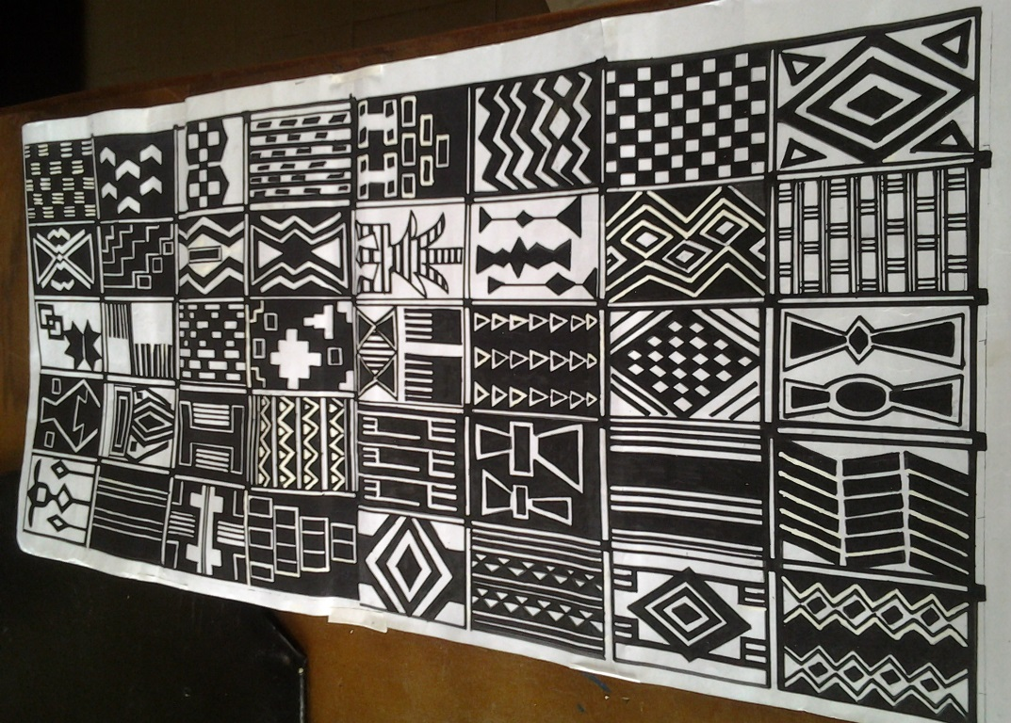

**Collection of Akwete woven symbols. Source: Researcher (2015)**

**References**

Adetoro, S.A. (1984). *Nigeria Textiles: traditional woven fabrics.* London: Cwi Press.

Akinbileje, T.U. (2014) Symbolic values of clothing and textiles art in traditional and

contemporary Africa, *international journal of Development and sustainability, vol. 3 No. 4 pp 626-641.*

Aniakor, C.C (2002) Art in the culture of Igbo land in ofomata, G.E.K (2002) *A Survey of the*

*Igbo Nation*, Africana first publisher’s limited Onitsha Nigeria.

Aronson, L (1979) *weaving in southern Nigeria*, Skidmore College.Africa.uima.uiowa.edu/topic-

essays/show/19.

Aronson, L (1980) Patronage and Akwete weaving. *African Arts,* Vol.13, No 3, pp. 62-66+91

UCLA James S. Coleman African studies center

Aronson, L (1982) Popo weaving: The Dynamics of Trade in Southeastern Nigeria. *African Arts*

Vol.15, No.3, pp 43-47+90 UCLA, James S. Coleman, African Studies Center.

Cole, H and Aniakor, C (1986*) Art and Community,*Museum of cultural History, U.S.A. p.59

Chukueggu, C.C. (2000) The Traditional Weaving Technology in Nigeria: The Case Study of

Akwete. *Journal of Creative Arts*. 1(I)

Chukueggu, C.C. (1998). *Contemporary Nigerian art and its classifications*. Warri: Delsu

Consult Pub.

Chukueggu .C.C and Ogu J.C. (2013) Akwete Weaving in the Secondary Schools Curriculum in

Imo State: A Proposal. *The Crab*: *Journal of Theatre and Media Arts*, University of PortHarcourt

Davis, M (1974*) Akwete cloth and its motifs* African Arts, Vol. 7, No 3, pp 22-25UCLA, James

S. Coleman, African Studies Center.

Eicher, J.B. & Erekesima, T.V.(1987). Wrapper design of Nigeria market: design features off

Igbo women’s wrapper. Nigerian Magazine No. 140, Federal Ministry of Information and Culture.

Ekweme, R. (1974). The fabric of our nation:Akwete clothing beauty and tradition woven into

one. Http://www.rovinginsightorg. (retrieved 3rd April 2014)

Griffis, M (2008), West African Adinkra Symbols, History and meanings <http://Ezine>

Article.com/? expert=Mike Griffis.

Ikegwuonu, R.N. (1979). *Nigerian Textiles.* (MS.C Thesis), department of textile industries.

Leeds Universities.

Ikegwu, J.U. & Uzuegbu, J.O. (2015) Akwete traditional weaving for rural tourism in Nigeria.

*International Journal of Environment, Ecology, family and Urban Studies (IJEEFUS)* www.academia.edu/15187731/Akwete _traditional_weaving_for_rural_tourism in Nigeria. (Retrieved 1st November 2015).

Isiguzo, I.A (2015) African culture and symbolism, A Rediscovery of the seam of a fragmented

identity.www.crvp.org/seminar/05-seminar...

Kashim, I.B (2013) Visual and material culture in the context of Industrial design: The

contemporary Nigerian Experience cdn.intechopen.com/pdfs-wm/43458.pdf

Lamb, V & Holmes (1980*) Nigeria weaving,* the shell petroleum Development Company of

Nigeria limited. Lagos.

Nwachukwu M, &Ibeabuchi, A.O. (2012). Blogspot.com/2012/08/Nigeria-akwete-Cloth-Igbo-

Textile-art.[www.vanguardngr.com/2012/07/akwete_an_Igbo_textile_art](http://www.vanguardngr.com/2012/07/akwete_an_Igbo_textile_art). Retrieved 2nd April 2014.

Ogu, J.C. & Ndebilie C. (2011) Akwete Cloth Weaving for sustainable Development

:Implications for Secondary School Curriculum. *Journal of Occupation and Training*, 5(2).

Okeke, C.S. (1996). Textile and fashion in modern Nigeria*. Uso Journal of Arts*. 1(2)

**APPENDIX**

**Akwete woven cloth symbolic motifs**

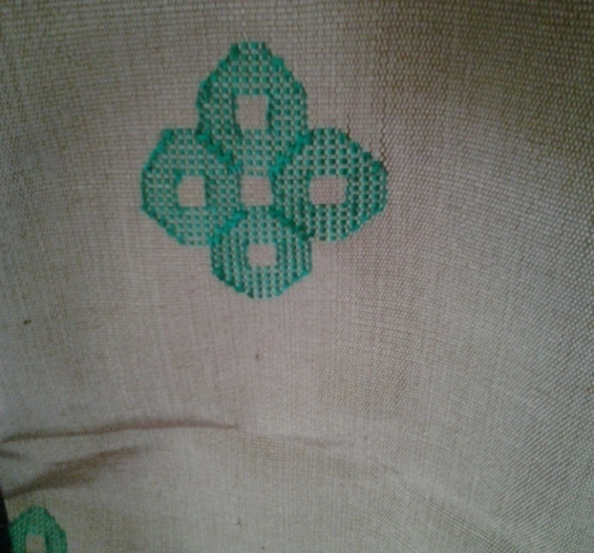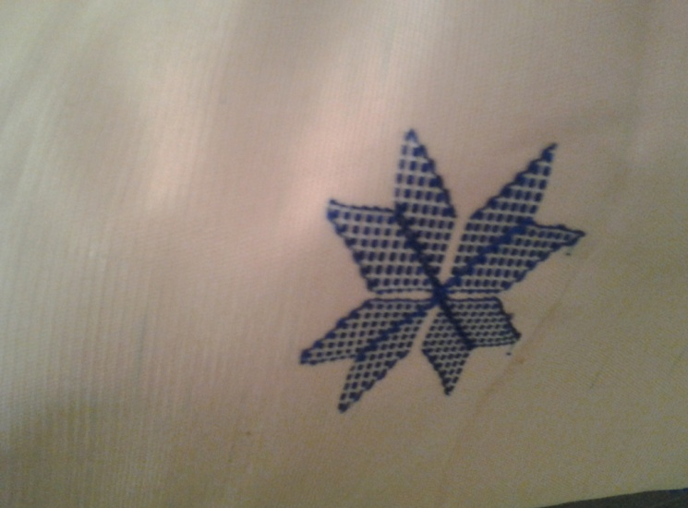

Ahia. Source: researcher (2015) Kpakpando. Source: researcher (2015)

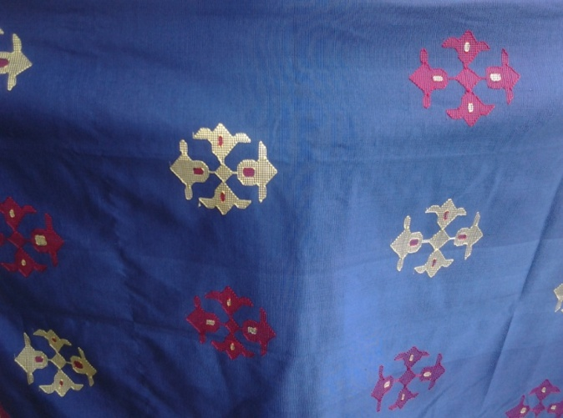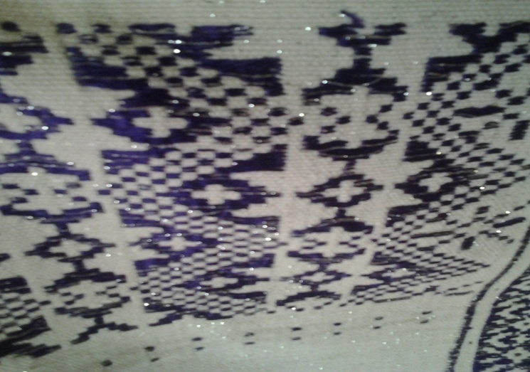

. Doublebells. Source: researcher (2015).

Checker board- A modern Akwete design

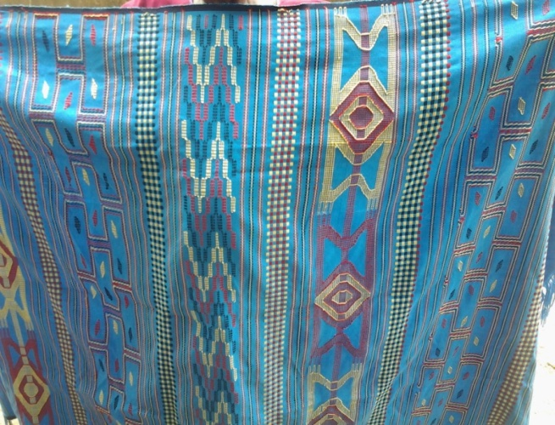Source researcher (2015).

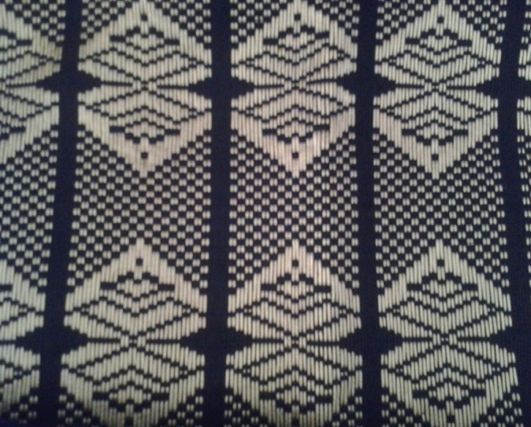

Ikaki, Igbe akwukwo, woven by Mrs. Butterfly motif, Source: researcher (2015)

Nneoma Okere igbere ndi oma na

Ute motifs. Source: researcher (2015).

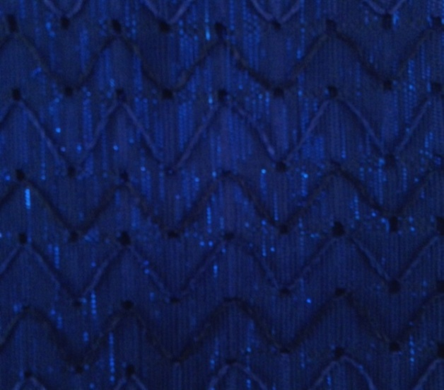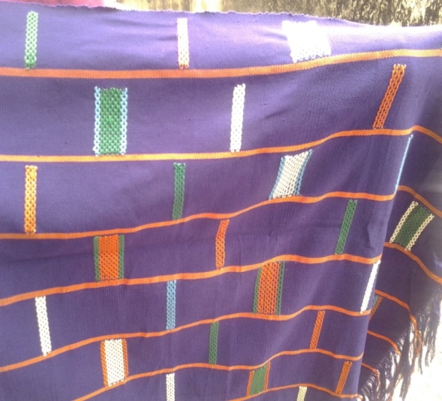

Popo. Source: researcher (2015) Baby lace. Source: researcher (2015)

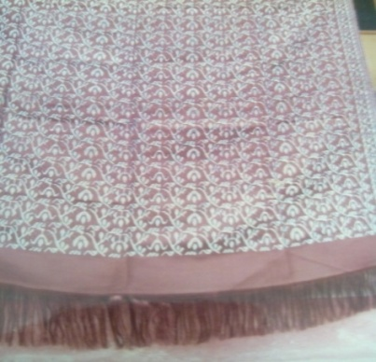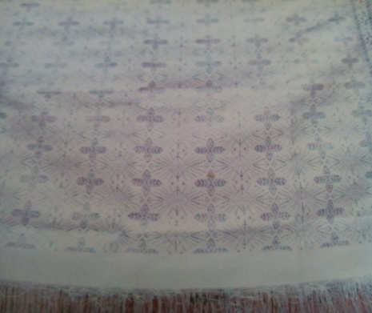

Recent Akwete design motifs (no name) woven by Recent Akwete design motifs(no name)woven by

Lady P.A. Odor in Akwete town, Source: researcher Lady P.A. Odor in Akwete town, Source: researcher

(2015) (2015)

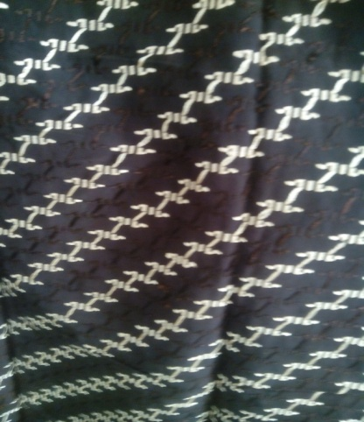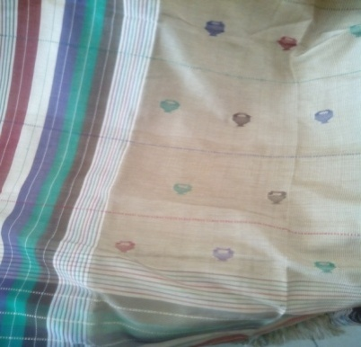

First lady woven by Mrs. Brown in Akwete George design woven by Lady .P. Odor. Town Source: researcher 2015 Source: researcher 2015

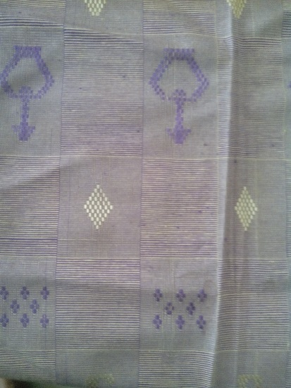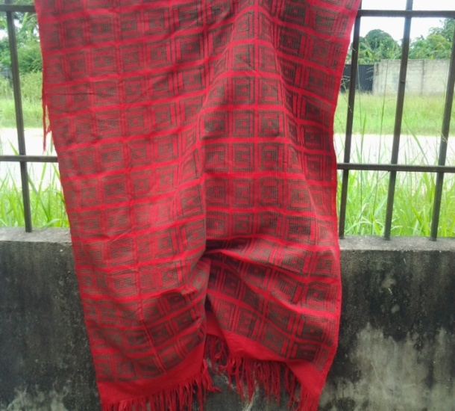

Fancy block woven by Mrs. Nneoma Okere in A Woven Design woven by Lady .P.

Akwete. Source: researcher 2015 Odor. Source: researcher 2015

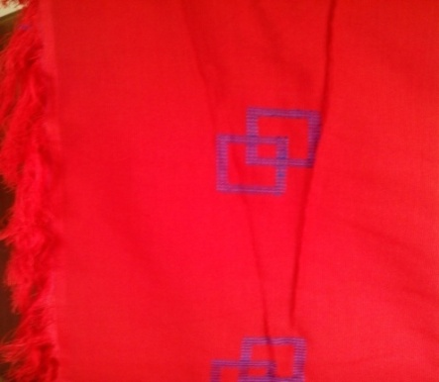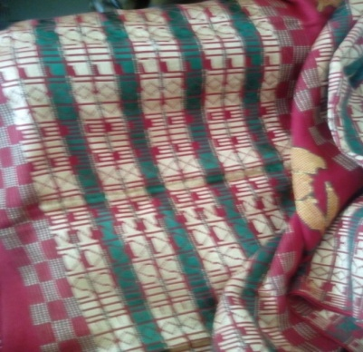

George design woven by Lady .P. Odor. Block Motif. Lolo Uchegbu’s private

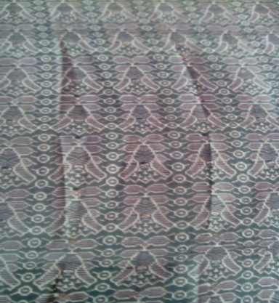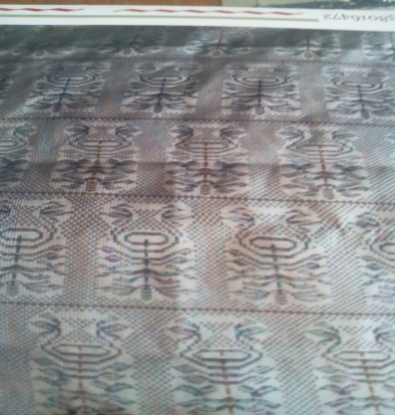Source: researcher 2015 collection used as uniform ndi lolo

A Woven Design woven by Lady .P. A Woven Design woven by Lady .P.

Odor. Source: researcher 2015 Odor. Source: researcher 2015

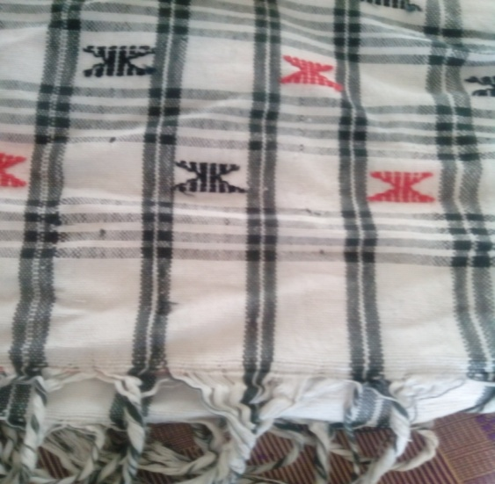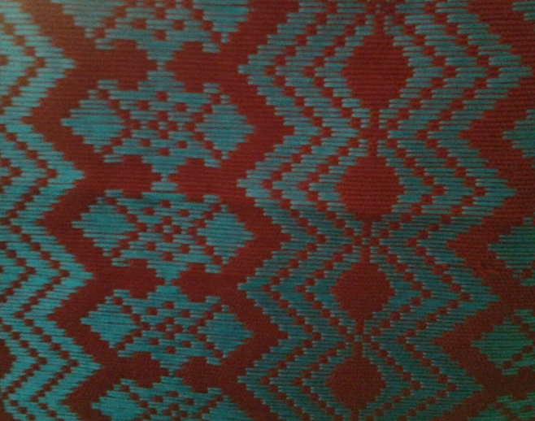

Mgbawa tomatoes motif. Source: Researcher 2015 Ebe motif by Lady P. Odor. Source:

researcher 2015

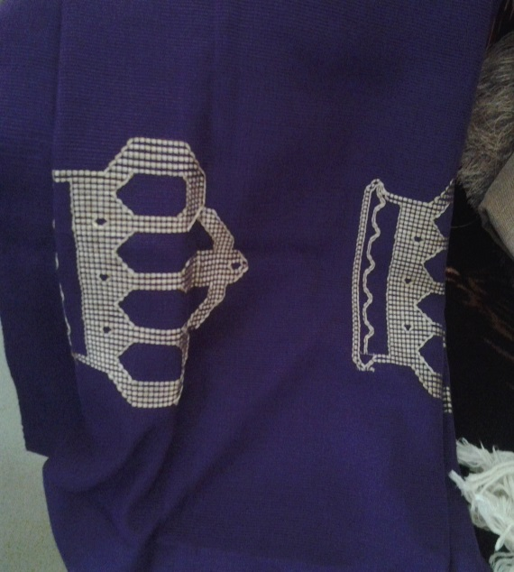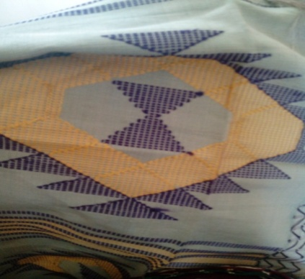

Mirror in the sun. source: researcher 2015 Okpu Eze motif. Source: Researcher 2015

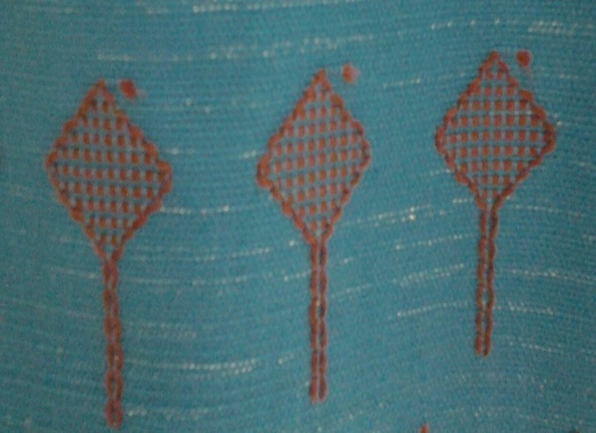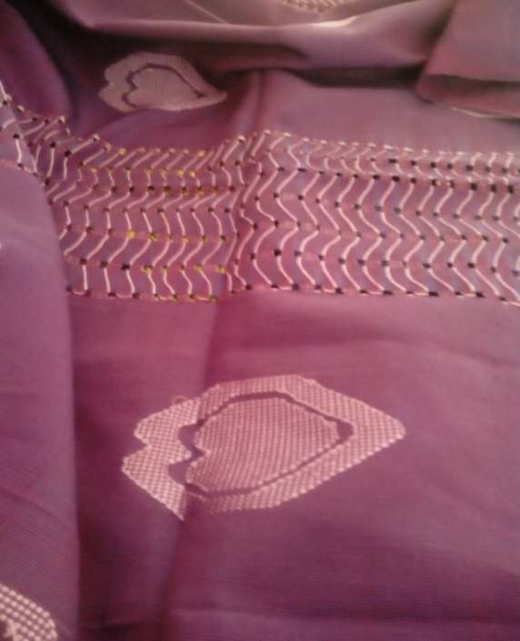

Children’s heart and baby lace motifs.

Source: researcher 2015 Hand fan motif. Source: Researcher 2015

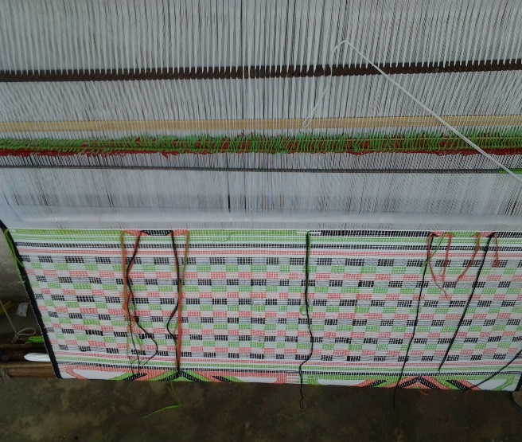

Mkpuru Sugar motif. Source: researcher 2015